Laugh Your Past Off!
Rodney Laney’s Prescriptions for Light-Hearted Living

RODNEY LANEY was born and raised in Paterson, New Jersey and is a born comedian. As a toddler, he would entertain at family gatherings. Laney’s real comedy career started capriciously while in the Air Force. He was stationed at Wright Patterson Air Force Base in Dayton, Ohio where he accompanied a fellow airman, an amateur comic, to a comedy club. His friend bombed, but Rod took the stage and received thunderous applause. It was instant addiction.

Rodney Laney has been seen on HBO, Comedy Central, FOX News Channel, The Late Late Show and CBS, TBS and the BBC. He has also appeared at the prestigious Just for Laughs Comedy Festival Montreal, and many others. He has executive produced and acted in feature films.

Rodney’s first CD I Blame the Publik Skool System was released by Comedy Dynamics. Determination may be Rodney Laney's biggest asset; according to his credit report, his only asset. If you want to laugh yourself out of your seat and have a genuinely uplifting experience, Rodney Laney is the ticket. Rodney’s book is humorous and provocative as Laney describes his journey into meditation and spirituality. Lighten Up! A Hilarious Memoir and Guide to Reflective Meditation, published by Post Hill Press, distributed by Simon & Schuster.
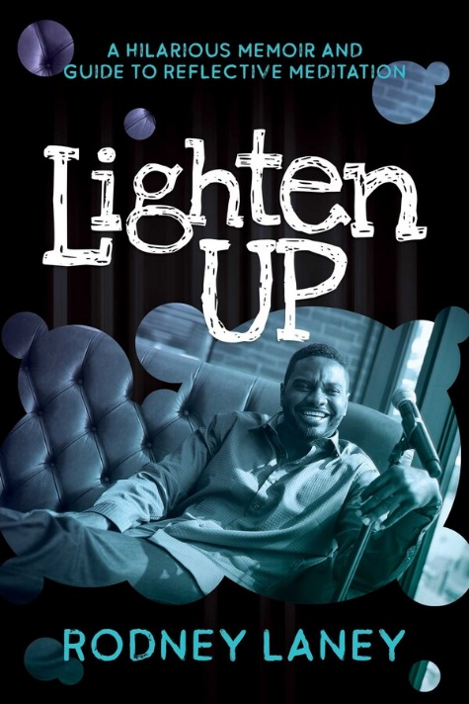

Rodney is available for corporate events, conferences, private parties, NPOs, comedy clubs, college & universities, etc.

Rodney’s Transformational Speaking Topics Include:
Meditation- The Power to Decipher, Discard, and Develop
Ground Hog Day- Awaken a Brand New You

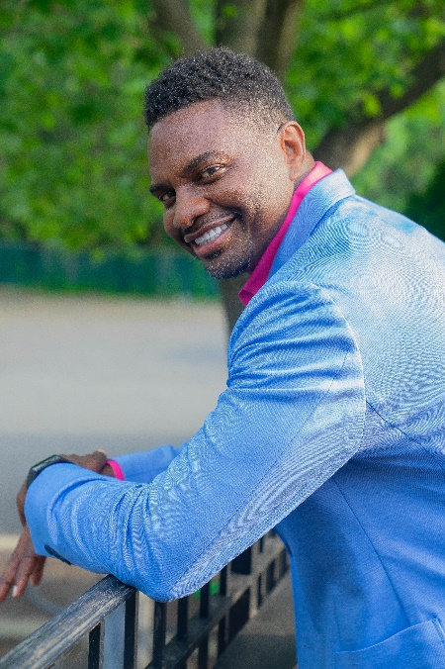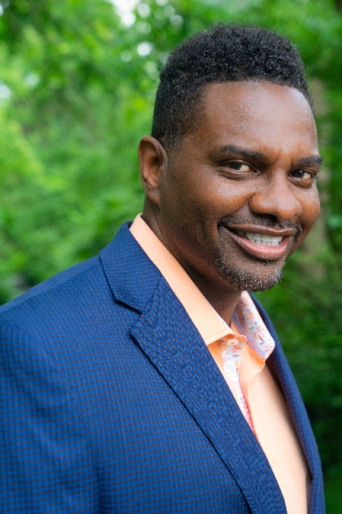

Rodney’s Comedic Routines Include:
Laugh Your Past Off!
One Hour Photo- The Art of Aging Gracefully
I’ll Swim Back to AMERICA! Rodney’s Eye-Opening Travel Expose’
I Blame the Publik Skool System
Aim High with the Air Force!

“I Love Your Show!” TV personality, Chrissy Teigen
“You are clever and hilarious! So witty and extremely personable.”
Comedian and actor, Robin Williams
“Your comic timing is impeccable!” Byron Allen, comedian, television producer, philanthropist, and the head of Entertainment Studios

